DeVry University – EET 202L (*Laboratory Report Cover Sheet)

Experiment / Assignment #2
Clocked D Latches & D Flip Flops

Name(s) | Professor: Ron Surprenant
*Summary (two sentences):

________________________________________________________________________
*Report Checklist (Include the following sections in your report):
1. Introduction & Background |  | 4. Results: Data, Tables, & Diagrams
2. Procedure |  | 5. Analysis of Results
3. Troubleshooting & Testing |  | 6. Conclusions
*Key Results:

________________________________________________________________________
Deliverables: All sections that contain a deliverable are identified with an *.
- This Lab. Report Cover Sheet with Summary & Key Results responses.
- Section A-3: Copy of dff1.gdf file.
- Section A-4: Copy of dff1.rpt file.
- Section B-7: Completed truth table.
- Section C-2: Instructor’s Sign-off
- Section E-4: Scope time measurements & Instructor’s Sign-off
- V. Questions.
- Lab Report

Student(s) Signatures | Date Submitted:

- SECTION B-7

PRE | CLR | D | CLOCK | Q | Q_NOT
1 | 0 | 0 | ↑ | 0 | 1
0 | 1 | 1 | ↑ | 1 | 0
1 | 1 | 1 | ↑ | 1 | 0
1 | 1 | 0 | ↑ | 0 | 1

Clocked D Latch Truth Table

- SECTION E-4

V. QUESTIONS
- Why is the condition when both and 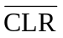are LOW considered illegal?
This is because it will set the circuit into an eternal toggle state.

- Why doesn’t the Q output follow the D input in the 74LS74 when either or is LOW?
This is because the preset and clear functions are inputs that override the synchronous D input. The preset function locks the circuit into the perpetual state that it was in when it is enabled; while the clear switches the circuit to a constant LOW.

- How does the value you measured for t_{setup} compare with value specified in the 74LS74 data sheet? You may need to go on-line to find this value.
According to the 74LS74 data sheet, the chips’ setup time is approximately 20ns. However; during my measurements I obtained results that were around 8ns for the setup time of the chip.
- The 74LS74 uses a positive edge detector as shown on page 453 of Floyd. Draw the circuitry for a negative edge detector. The circuit must generate a very narrow, positive going pulse when the input goes negative.
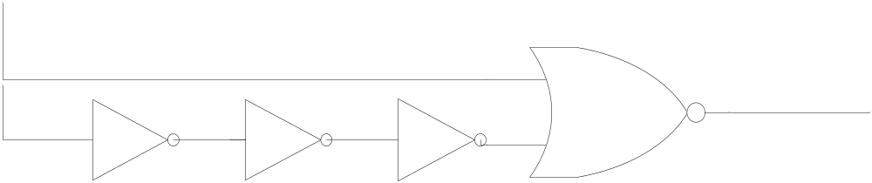

1. Introduction and Background
This experiment is an attempt to become more familiarized with the simulation and common operation of the Gated D-latch. This latch differs in that its clock input activates the circuit only upon its rising edge, creating an “edge-triggered” gate.

2. Procedure
  - Simulate a Clocked D- Latch with Asynchronous and Synchronous inputs.
  - Run the simulation and verify that it is operating properly, using a simulated set of inputs to demonstrate the latches operation.
  - Build a hardwired D Flip Flop using the EET202 parts kit and accessories.
  - Using the circuit, verify that the truth table hold true.
  - Finally, measure the setup time for the circuit using the scope. Measure the clock input for the signal and compare it with the Q output of the 74LS74 IC

3. Troubleshooting and Testing
The main problem that I ran into during this experiment was during the simulation part of the lab. After I had entered my Gated D-Latch into the GDF format I ran its corresponding simulation and discovered that the output for my circuit (Q) was staying at a solid LOW throughout the entire timing diagram. I checked for the following things:
- Any mistakes in the GDF file. Couldn’t find anything.
- Then I thoroughly scanned my SNF timing diagram.
I found that I had improperly set the inputs for the latch. I rechecked the D input was set to a constant LOW. I also realized that I hadn’t set the clock. After setting the clock so that each wave would repeat itself after a period of 50ns, and a data period of 100ns, my timing diagrams’ outputs looked much better.

4. Results: Data, Tables, Diagrams

PRE | CLR | D | CLOCK | Q | Q_NOT
1 | 0 | 0 | ↑ | 0 | 1
0 | 1 | 1 | ↑ | 1 | 0
1 | 1 | 1 | ↑ | 1 | 0
1 | 1 | 0 | ↑ | 0 | 1

Clocked D Latch Truth Table

5. Analysis of Results
My main result that the two manufacturers data sheets for the two different chips is that it is noticeable that the setup time as laid out by the manufacturer is 2.5 times greater than what my measurements where. As I thought this was a strange result, I confirmed that each of the Inverter gates were operating with somewhere around 8ns of switching time. I found that after I used all of the gates on the 74LS04 IC I was able to get a T _{(setup)} time of around 31.8 ns.

6. Conclusions
In conclusion this lab had accomplished the following:
- Demonstrated that all electronic systems have some inherent form of delay. (as of yet)
- Replicated results found my manufacturer eventually; however it did appear that the manufacturer created the spec sheet based on worst case scenario.
- Showed clearly how a gated D-Latches Asynchronous inputs relates with the rest of the gate (that is that they nullify any other input)
- Verified the operation of a Positive and Negative Edge Detection circuit.

